Integration and mission execution
The workflow that is integrated links the sprayed weed positions, as well as the synthesised drone movement and the processed weed positions. The processed coordinate output contains target positions and the decision output determines the need to spray each zone with spot or blanket spray. The integration layer uses this information to create waypoint-like mission information. The intended flow of projected weed coordinates, spray decision result, waypoint command, drone movement and spray action log are included.
This format, which is easy to check and debug, was adopted: x, y, z, spray-type. In case of a drone moving to the incorrect position, live coordinates may be directly verified. In case the false spray action is shown, the spray_type field may be conducted until the decision output. Using the simulation, the drone is able to navigate through target waypoints during mission execution and print or display actions SPOT SPRAY or BLANKET SPRAY. This is a good illustration of the concept without a physical spraying mechanism.
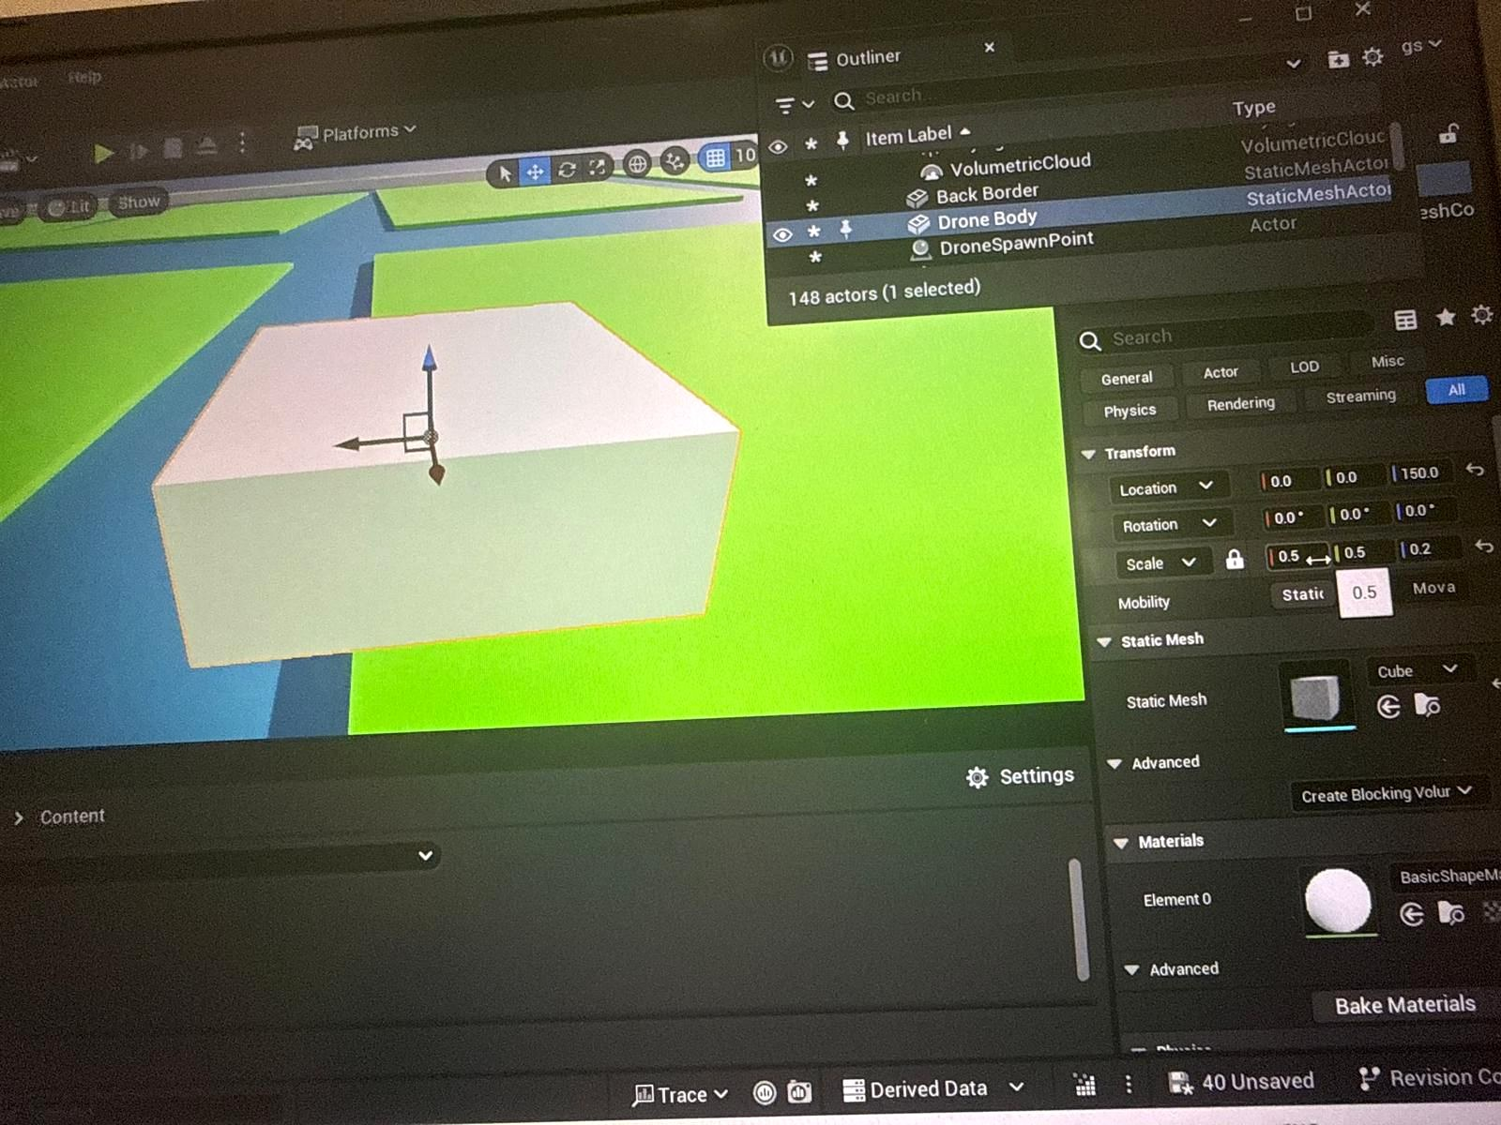
Figure 5: Simulation view prepared for integrated mission execution and waypoint testing.

Testing and evaluation
The surrounding was also tested by looking at the field through various angles in Unreal engine. The primary test was the visibility and comprehensibility of crop plots, weed spots, waterways, borders, and drone locations. The grid was effective due to the ability to see the field in an aerial view, which aligns with the target application with a drone as a monitoring tool. Colours were also used to be able to identify the areas of health and those affected by the weed in the screenshots and demo video content.
The workflow of integration was tested by determining the possibility of transforming coordinate-style results to waypoint and action data. The anticipated successful outcome is acceptance of target locations by the mission, ability to utilize a target location in the mission flow, and the ability to visualize the appropriate action of simulated spray in the correct location at each waypoint. The prototype is also viable as it proves the main concept: the data related to the weed-zone can be handled, modeled in simulation, and linked to a drone workflow.
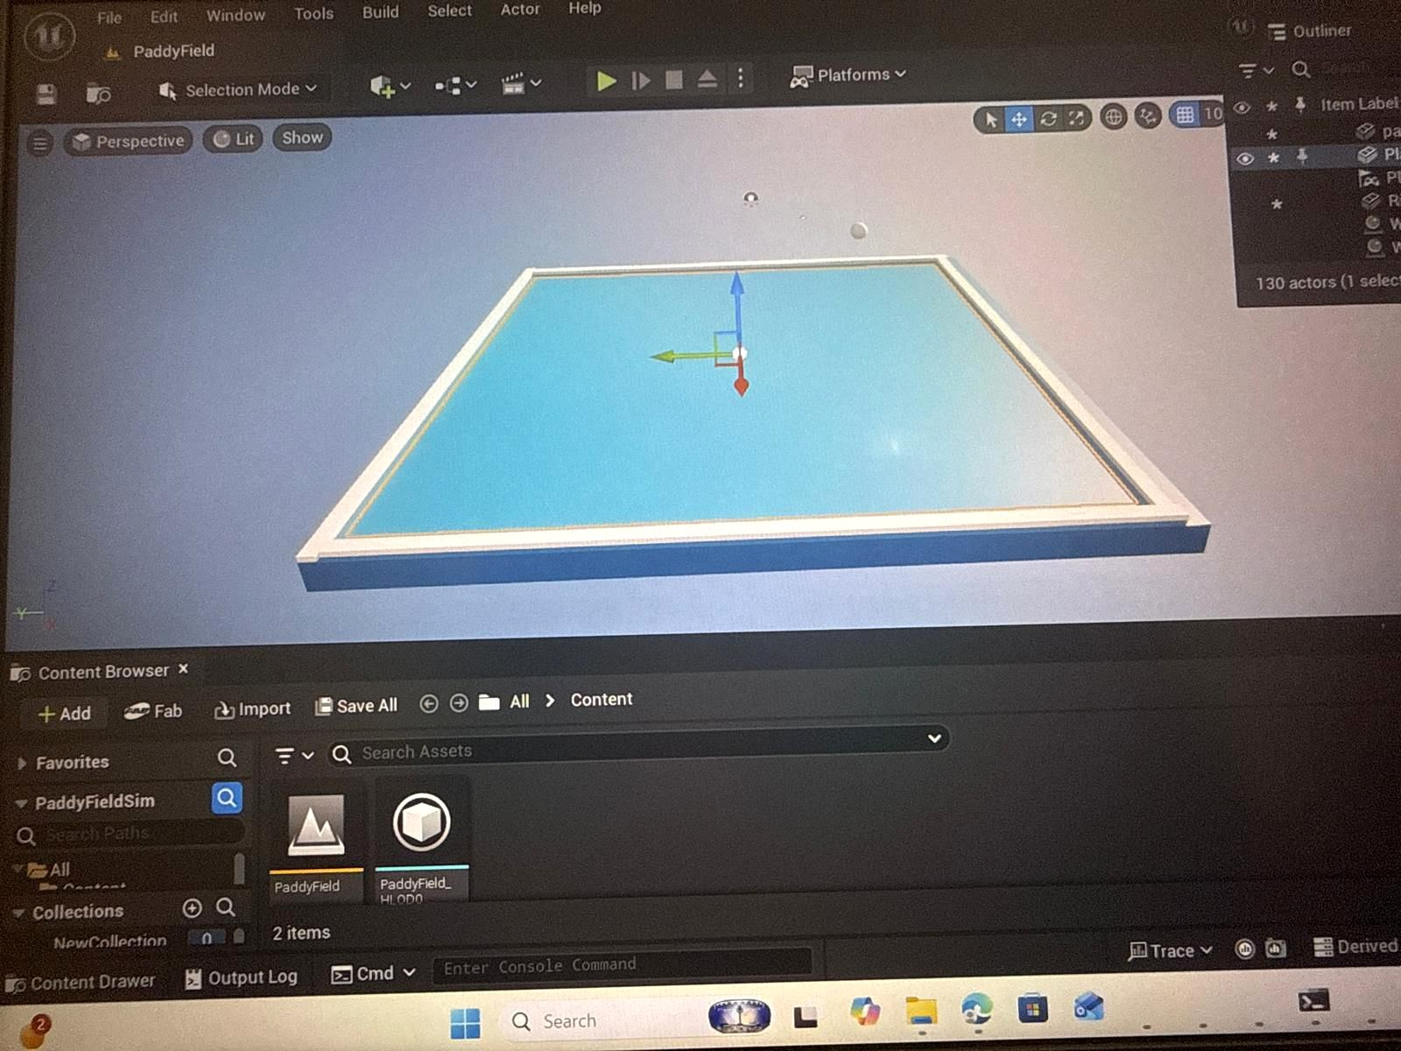
Figure 6: Final paddy field environment view showing the completed simulation area.

Limitations and future improvements
The system that is in place is an experiment. Weed zones are mapped visually, instead of being identified by an actual computer vision model. Water canals and agricultural areas are inanimate and the surrounding environment does not simulate weather, plant growth, soil state and water flow. Output logs or messages are also used to simulate spraying as opposed to a real sprayer. These restrictions are fine at present phase as the goal of the work is to illustrate the technical process.
A realistic plant model, terrain variation, animated water, the level of weed density, and a visible spray particle effect could be added to work in the future. The KML input could be more fully validated, and converted to local simulation coordinates and edge cases, e.g., empty data, or noisy coordinates could be checked. Extendions of the integration workflow might include route optimisation, obstacle avoidance, battery constraints, and return-to-home behaviour.

Ethical and professional considerations
The area of drone-based agricultural monitoring needs to be mindful of privacy, safety as well as responsible handling of the data. In actual field deployment, the collection of the drone footage and the location of the farm must be taken only after authorization by the farmer/landowner. The system must not capture unneeded photos of individuals, homes, streets or surrounding privation. Data that is gathered should be secured and must be used appropriately towards the purpose of agricultural use.
The fact that one uses a simulation environment is also professionally accountable since risk is mitigated, prior to similar testing in real-life scenario. Mission logic and spray-action are testable by the team without destroying crops, trespassing on personal land, or posing safety risks related to drones. Quality assurance can be assisted by simulation since errors can be detected and rectified prior to physical implementation.

Project management contribution
The project was done according to the intended sequences. At the beginning stage, emphasis was laid on comprehending the project pipeline and coordinate requirements. In core development, the paddy field environment had been constructed and the test data of the weed-zone was prepared. In the integration, the finished products were linked to the mission execution in waypoint fashion. The last step was to prepare screenshot, logs and demonstration evidence to include in the report and video.
This was a theatrical method to aid the project to push beyond data preparation, environment creation, and on to mission execution. The prototype was tested in a real environment and the workflow provided an understanding on how individual modules can reflect themselves as a single system.

Risk Analysis
Risk ID | Risk Description | Impact | Likelihood | Mitigation Strategy
R1 | Unreal Engine environment crashes or project corruption | High | Medium | Maintain regular backups and version control through GitHub.
R2 | Incorrect weed-zone coordinates generated during processing | High | Medium | Validate coordinate outputs using test datasets and visual verification.
R3 | Integration failure between processed data and navigation module | High | Medium | Use standardized data formats and conduct incremental integration testing.
R4 | Drone unable to reach designated waypoints in simulation | Medium | Medium | Test waypoint generation with small datasets before full deployment.
R5 | AirSim compatibility issues with Unreal Engine version | Medium | Low | Use supported versions and verify compatibility before implementation.
R6 | Missing or corrupted input files (KML/coordinate data) | Medium | Medium | Create backup datasets and implement input validation checks.
R7 | Performance degradation due to complex environment assets | Medium | Medium | Optimize meshes, textures, and foliage density.
R8 | Incorrect weed classification affecting mission output | High | Low | Validate classification results using sample scenarios before integration.
R9 | Data transfer errors between modules | Medium | Medium | Use structured formats such as JSON or CSV and perform validation checks.
R10 | Schedule delays caused by dependency on other modules | Medium | Medium | Conduct regular team reviews and follow the project timeline closely.

Conclusion
The environment development and integration activity was completed effectively and provided the practical format of the prototype of spraying drones in paddy field. The finished field consists of crop plots, weed areas, irrigation, and borders, lighting, and positions of drone. Integration workflow links processed weed-location information and spray decision information to waypoint-like mission execution and simulated spray operations.
The system is not a complete real-world spraying application but, nevertheless, it illustrates the key idea of the project. It demonstrates how intelligent farming data can be digested, visualised in a simulation space and applied to make decisions on drone-based monitoring and spraying.

